**Step 1: Find the data** – Find a source of text-based data (e.g., a newspaper article, a story, lyrics to a song, your resume, etc.) that you want to analyze.

I leveraged my resume to generate World clouds. I wanted to analyze what is the summary and key items that are popping out from my 1400 word long 2 page resume

**Step 2: Create word clouds** – Find a tool that can create “word clouds” on web. Use at least 2 tools to generate “word clouds” from the text-based data source you found in Step 1. Play around with different visualization options of the tool (e.g., letter case, color, number of words included in the analysis, etc.). You can use the wordle.net that is mentioned in the lecture. Some additional tools for generation “word clouds” include:

I used 2 sites to generate the word clouds.

* Wordle has been re-christened as <http://www.edwordle.net/create.html>
* Word clouds from website <https://www.wordclouds.com/>

Outputs are as below

[**https://www.wordclouds.com/**](https://www.wordclouds.com/)



[**http://www.edwordle.net/create.html**](http://www.edwordle.net/create.html)

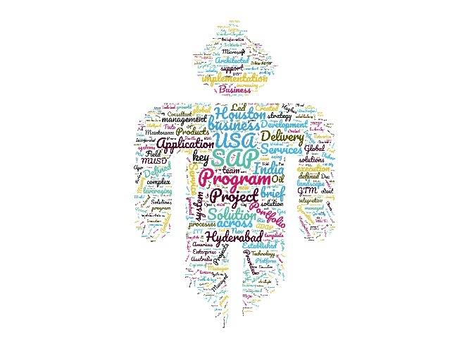

**Step 3: Compare the tools in terms of capability** – Explain how are the tools you used to generate “word clouds” differ in their breadth of functionality, flexibility, and ability to produce graphics (e.g., color changes, graphical formats, orientation shifts, etc.). Provide your own opinion on the effectiveness of the visualization produced by the tool.

**EdWorld:** I think this has some cool features which focusses its attention of summarizing a great level of detail into concise summary. Its features ae focused on “grouping similar words”, “removing similar words”. Reasonable options to change layouts and adjust font colors. Focus is on summarization

**Wordclouds.com :** This site’s landing has a lot more features with focus on visualization. It provides several options including custom images based on which the world cloud is produced. The focus of these tool seems visualization

**Step 4: Compare the tools in terms of ease of use** – Compare the tools on their respective ease of use, exploring how quickly one can reasonably expect to learn the tool, how intuitive it is, and any special skills required for its use.

In terms of the ease of use, I found Edwordle to be simple and easier to use than wordcloud. For someone who is relatively tech savvy and has reasonable experience, wordcloud can be a better option due to the sheer flexibility based on the number of features and options it has to offer